Data Processing Reading 1

Thom Mekelenkamp

1. My virtualization

The image above is the virtualization of the 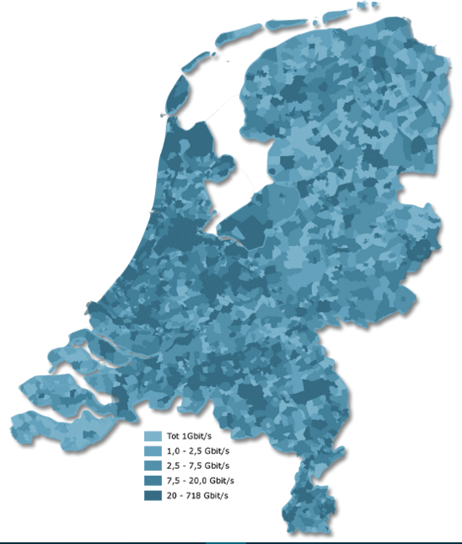network speeds that the companies use together in a specified area. The virtualization source is: http://www.destaatvantelecom.nl/#infrastructuur-5



Value:

The values on the map are indicated by a blue color in different shades of blue. The denser areas with more bandwidths have a darker color. This is a logical way to implement the color values: darker color 🡪 more bandwidth. The value selective is a bit hard to determine right or wrong. Because the shapes of the different districts are made up from the official districts in the Netherlands. The creator of this visualization couldn’t do that much to change that shape.

Color:

The map that I chose looks like map2 on page 14. The image consists of one color. Even though it is only one color the image is still easy to read because it is in different shades of blue. One thing is that there is no dark line that separates the districts in this image. That would have made it easier to read, and less likely to make mistakes in the color of the districts. The different shades of blue make it easy to group multiple districts according to the color that they have.

1. Virtualization as functional art

In my opinion is virtualization functional art. This is because the creator of the virtualization has 1001 things to take into account when creating it. With that I think that a lot of virtualizations of data are not just meant to represent the numbers. They are made to carry out a message. For example a graph with the number of people in the world who are overweight. A virtualization like that isn’t just saying how many people are overweight. It makes people think about those numbers; is this important, bad or good? And in that way is a creator of data virtualization also an artist.

1. function
2. The graphic represents the network speeds that companies are using together per district. The only variable in the graph is the network speed.
3. It should allow comparisons. It is possible to tell the difference between several districts. With that the graph also represents general information about the network speeds.
4. It should help me to see which district uses the most network bandwidth. Which could help me choose if whether I want to place my datacenter in a very busy district or not.
5. The graph can help met with multiple things:

* I can see the network speed per district
* With the knowledge of the speeds I can determine how much companies are in each district.
* With the information of possible number of companies in an area it will be possible to determine the densest populated areas on the map.